LP 5 THEORY
Introduction to Distributed System
https://www.geeksforgeeks.org/computer-networks/what-is-a-distributed-system/
A distributed system is a group of independent computers, called nodes, that work together as a single system. These nodes communicate over a network to share data, resources, and tasks to achieve a common goal. It ensures coordination between multiple systems while appearing unified to the user.
Example: An online shopping platform like Amazon uses distributed systems where multiple servers handle different tasks such as product search, payments, and order processing. Even if one server fails, the platform continues to function without affecting the user experience.

Assignment 1: Implement multi-threaded client/server Process communication using RMI.
https://www.geeksforgeeks.org/java/remote-method-invocation-in-java/
Remote Method Invocation (RMI) in Java is an API that enables an object in one JVM to invoke methods on an object located in another JVM, either on the same machine or a remote system. It supports building distributed applications by allowing seamless client-server communication through method calls.
The communication between client and server is handled by using two intermediate objects:
Stub object (on client side) and Skeleton object (on server side).

Stub (Client-side Proxy): It acts as a proxy for the remote object and forwards method calls from the client to the server.
The block consists of
- An identifier of the remote object to be used
- Method name which is to be invoked
- Parameters to the remote JVM
Working of RMI
Communication between client and server is handled using a Stub (client-side proxy), while server-side request handling is managed internally by the RMI runtime.
Note: In earlier RMI versions, Skeleton was used on the server side, but it is now deprecated and no longer required.
Steps to implement RMI
Step 1: Defining the remote interface
Step 2: Implementing the remote interface
Step 3: No need to generate Stub/Skeleton manually
Step 4: Start the rmiregistry
Step 5: Create and execute the server application program
Step 6: Create and execute the client application program

**********************************************************************

Assignment 3: Implement Berkeley algorithm for clock synchronization

The Berkeley algorithm is a method of clock synchronisation in distributed computing which assumes no machine has an accurate time source.

Berkeley's Algorithm is a clock synchronization technique used in distributed systems. The algorithm assumes that each machine node in the network either doesn't have an accurate time source or doesn't possess a UTC server.
Algorithm
1) An individual node is chosen as the master node from a pool node in the network. This node is the main node in the network which acts as a master and the rest of the nodes act as slaves. The master node is chosen using an election process/leader election algorithm.
2) Master node periodically pings slaves nodes and fetches clock time at them using Cristian's algorithm.
The diagram below illustrates how the master sends requests to slave nodes.
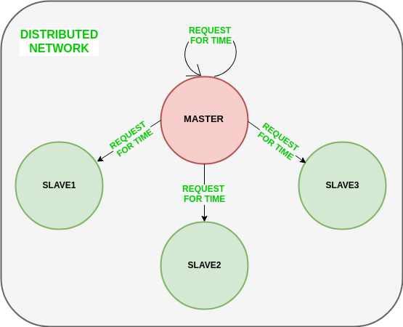
The diagram below illustrates how slave nodes send back time given by their system clock.
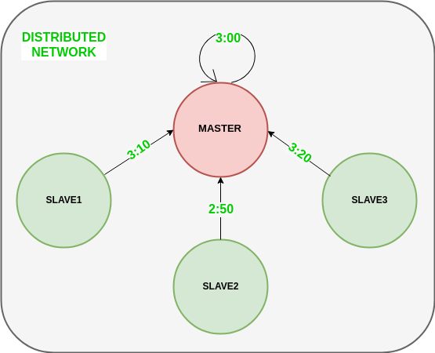3) Master node calculates the average time difference between all the clock times received and the clock time given by the master's system clock itself. This average time difference is added to the current time at the master's system clock and broadcasted over the network.
Pseudocode for above step:
1. total_diff = 0
2. n = number of nodes (including master and all clients)
3. For each node i (including master):
receive clock_time[i] // Time reported by each node
4. master_time = get_system_time() // Master's local clock time
5. For each node i (including master):
time_diff[i] = clock_time[i] - master_time
total_diff += time_diff[i]
6. average_diff = total_diff / n
7. adjusted_master_time = master_time + average_diff
8. Broadcast adjusted_master_time to all nodes
9. For each node i (including master):
set_system_time(adjusted_master_time)
The diagram below illustrates the last step of Berkeley's algorithm.
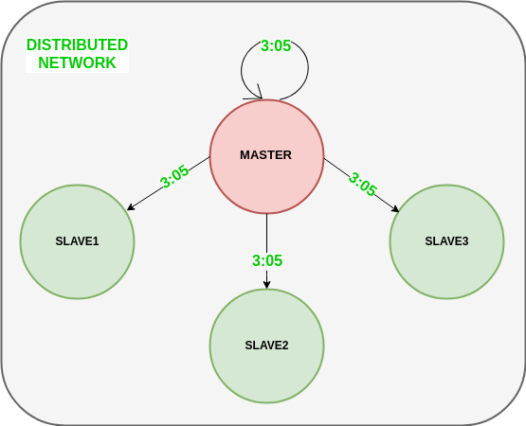
features of Berkeley's Algorithm:
Centralized time coordinator: Berkeley's Algorithm uses a centralized time coordinator, which is responsible for maintaining the global time and distributing it to all the client machines.
Clock adjustment: The algorithm adjusts the clock of each client machine based on the difference between its local time and the time received from the time coordinator.
Average calculation: The algorithm calculates the average time difference between the client machines and the time coordinator to reduce the effect of any clock drift.

Limitations and Improvements
Berkeley's Algorithm has several limitations that can be addressed:
- Accuracy The algorithm calculates the average time based on the timestamps received from all computers, which can lead to inaccuracies, especially if the network has high jitter or delay.
- Robustness The algorithm requires a master computer, which if it fails, can cause the entire synchronization system to stop working.
- Clock Drift The algorithm assumes that all clocks run at the same rate, but in practice, clocks may drift due to temperature, aging, or other factors

**********************************************************************

Assignment 4: Implement token ring based mutual exclusion algorithm.
https://www.tutorialspoint.com/article/mutual-exclusion-in-a-distributed-system
https://www.geeksforgeeks.org/operating-systems/mutual-exclusion-in-distributed-system/
Mutual exclusion in a distributed system
Mutual exclusion in distributed systems is a fundamental principle that prevents concurrent processes or nodes from simultaneously accessing shared resources or critical sections. When multiple processes attempt to access the same resource concurrently, it can lead to race conditions, data corruption, and system inconsistencies.
Unlike centralized systems, distributed systems lack shared memory and face challenges such as network delays, communication failures, and node failures. These factors make implementing mutual exclusion significantly more complex, requiring specialized algorithms and protocols to ensure proper coordination between distributed nodes.

Requirements of Mutual exclusion Algorithm:
- No Deadlock: Two or more site should not endlessly wait for any message that will never arrive.
- No Starvation: Every site who wants to execute critical section should get an opportunity to execute it in finite time. Any site should not wait indefinitely to execute critical section while other site are repeatedly executing critical section
- Fairness: Each site should get a fair chance to execute critical section. Any request to execute critical section must be executed in the order they are made i.e Critical section execution requests should be executed in the order of their arrival in the system.
- Fault Tolerance: In case of failure, it should be able to recognize it by itself in order to continue functioning without any disruption.

Mutual exclusion in single computer system Vs. distributed system: In single computer system, memory and other resources are shared between different processes. The status of shared resources and the status of users is easily available in the shared memory so with the help of shared variable (For example: Semaphores) mutual exclusion problem can be easily solved.
In Distributed systems, we neither have shared memory nor a common physical clock and therefore we cannot solve mutual exclusion problem using shared variables. To eliminate the mutual exclusion problem in distributed system approach based on message passing is used. A site in distributed system do not have complete information of state of the system due to lack of shared memory and a common physical clockin distributed system do not have complete information of state of the system due to lack of shared memory and a common physical clock.

Solution to distributed mutual exclusion
Mechanism | Description | Key Feature
Lock-Based | Processes acquire locks before accessing resources | Exclusive or shared locks
Token-Based | A unique token circulates among processes | Only token holder can enter critical section
Timestamp-Based | Processes receive timestamps for ordering | Earlier timestamps have higher priority
Quorum-Based | Requires majority approval from node groups | Fault-tolerant through voting
3. Quorum based approach:
- Instead of requesting permission to execute the critical section from all other sites, Each site requests only a subset of sites which is called a quorum.
- Any two subsets of sites or Quorum contains a common site.
- This common site is responsible to ensure mutual exclusion

Token Ring Algorithm
The Token Ring Mutual Exclusion Algorithm is a distributed algorithm used to control access to critical sections.
It uses:
- Logical ring structure
- Special message called a token
Core Idea of Token Ring Algorithm
Only the process holding the token is allowed to enter the critical section.
The token continuously circulates among processes in a ring.
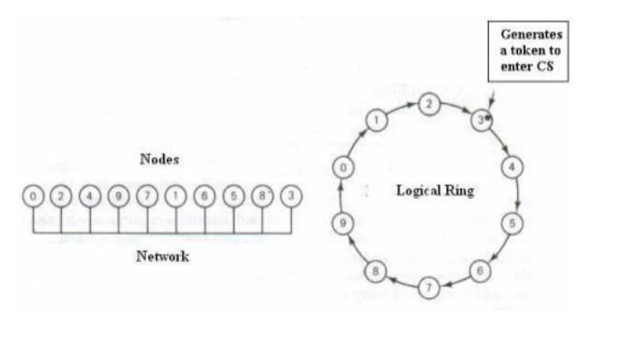
What is a Token?
A token is a special permission message.
Properties:
- Only one token exists in system
- Possession of token grants access
- Token circulates continuously

Working of Token Ring Algorithm
Step 1: Token Circulation
Token moves from one process to another in ring order.
Step 2: Process Receives Token
When a process receives token:
Case A: Wants Critical Section
- Process enters critical section
- Executes task
- Releases critical section
- Passes token forward
Case B: Does Not Need Critical Section
- Immediately forwards token

10. Important Properties
A. Safety
Only one token exists.
Therefore:
- Only one process enters critical section
Hence:
- Mutual exclusion guaranteed
B. Fairness
Every process eventually receives token.
Therefore:
- No starvation
C. Deadlock-Free
Token continuously moves.
Processes do not wait indefinitely

12. Disadvantages of Token Ring Algorithm
1. Token Loss Problem
If token is lost:
- Entire system stops
Need token regeneration mechanism.
2. Ring Failure
If one process crashes:
- Ring communication breaks
3. Delay Under Light Load
Even if no one needs resource:
- Token still circulates

**********************************************************************

Assignment 5: Implement Bully algorithm for leader election.
https://www.educative.io/answers/what-is-a-bully-election-algorithm
https://www.geeksforgeeks.org/dsa/bully-algorithm-in-distributed-system/#what-is-the-leader-election-algorithm
1. Introduction to Leader Election
In distributed systems, many operations require one process to act as a coordinator (leader).
The coordinator may:
- Allocate resources
- Manage synchronization
- Handle communication
- Maintain shared state
If the coordinator fails:
- System must elect a new coordinator
This process is called leader election.

2. Definition of Leader Election
Leader election is the process of selecting one process as coordinator among multiple distributed processes.
Note: It is the goal of leader election algorithm to choose an appropriate leader and let every other node in the system know about the elected leader.

The election algorithm is based on the following assumptions:
- Each process has a unique priority number.
- All processes in the system are fully connected.
- The process with the highest priority number will be elected as coordinator.
- Each process knows the process number of all other processes.
- During recovery, the failed process can take appropriate steps to resume the set of active processes

What is the Bully Algorithm for Leader Node Election?(refer gfg for diag)
The Bully algorithm is a popular technique for choosing a leader in distributed networks that uses the greater priority concept. The process with the highest process ID becomes the coordinator. It operates as follows:
- Initiation: When a node detects that the current leader has failed (usually through a timeout mechanism), it initiates an election.
- Election Process:
  - The initiating node sends an "election" message to all other nodes with higher priority.
  - Nodes with higher priority respond by either acknowledging their current leader status or declaring themselves candidates.
  - If no higher-priority node responds, the initiating node assumes leadership.
- Notification: The newly elected leader informs all nodes of its leadership status, ensuring consistency across the distributed system.
Messages in Bully Algorithm for Leader Node Election
There can be three types of messages that processes exchange with each other in the bully algorithm:
- Election message: Sent to announce election.
- OK (Alive) message: Responds to the Election message.
- Coordinator (Victory) message: Sent by winner of the election to announce the new coordinator.

9. Working of Bully Algorithm (Step-by-Step)
Assume processes:
P0,P1, P2, P3, P4, P5
Current coordinator: P5
Suppose:
- P5 crashes

Step 1: Failure Detection
P2 notices:
- Coordinator not responding
P2 starts election.

Step 2: Election Messages
P2 sends election message to:
P3, P4, P5

Step 3: Higher Process Responds
P3 and P4 reply with OK message.
This means:
- Higher processes are alive
- P2 stops election

Step 4: Higher Process Starts New Election
P4 now conducts election.
P4 sends election to:
P5
No response from P5.

Step 5: New Coordinator Selection
Since nobody higher responds:
P4 becomes coordinator

Step 6: Coordinator Announcement
P4 sends coordinator message to all processes.
System updated.

Challenges of the Bully Algorithm for Leader Election
Below are the challenges of Bully Algorithm:
- Message Overhead: Nodes may need to exchange multiple messages during the election process, especially in larger networks or when nodes have similar priorities. This can introduce latency and increase network traffic, affecting overall system performance.
- Priority Assignment: Assigning priorities or identifiers to nodes in a fair and accurate manner is crucial. Incorrect or inconsistent priority assignments can lead to improper leader elections or instability in leadership transitions.

**********************************************************************
Assignment 6: Implement Ring algorithm for leader election.
https://www.educative.io/answers/what-is-ring-election-algorithm
https://www.geeksforgeeks.org/system-design/what-is-ring-election-algorithm/
The Ring Algorithm is a distributed leader election algorithm where processes are arranged in a logical ring and election messages circulate through the ring to determine the coordinator.
The process with the highest process ID becomes the new leader.
It ensures that only one node in the network becomes the leader, facilitating coordination and decision-making within the system.
How Does Ring Election Algorithm Work?
Below is how the ring election algorithm works:
- Step 1: Initialization: Each node in the network is assigned a unique identifier or priority.
- Step 2: Message Passing: The algorithm begins when a node initiates an election process. It sends a special message, often called an "election message" or "token," containing its identifier, to its neighboring node(s) in the ring.
- Step 3: Comparison and Forwarding: Upon receiving the election message, each node compares the identifier in the message with its own. If the received identifier is greater than its own, it forwards the message to the next node in the ring. If the received identifier is smaller than its own, it discards the message.
- Step 4: Propagation: This process continues until the message returns to the initiating node. As the message travels around the ring, each node updates its state to reflect the highest identifier it has encountered.
- Step 5: Leader Election: Once the message returns to the initiating node, it knows it has the highest identifier in the network. It declares itself as the leader.

8. Step-by-Step Working of Ring Algorithm
Assume processes:
P1 → P2 → P3 → P4 → P5
Current coordinator:
P5
Suppose:
- P5 crashes

Step 1: Failure Detection
P2 detects:
- Coordinator failure
P2 initiates election.

Step 2: Election Message Creation
P2 sends:
[ELECTION, 2]
to P3.

Step 3: Message Propagation
P3 receives message:
[ELECTION, 2]
P3 adds its own ID:
[ELECTION, 2, 3]
Forwards to P4.

P4 adds its ID:
[ELECTION, 2, 3, 4]

P5 is crashed → skipped.
Message eventually returns to P2.

Step 4: Highest ID Selection
P2 receives:
[ELECTION, 2, 3, 4]
Highest ID:
P4
Therefore:
P4 becomes coordinator

Step 5: Coordinator Announcement
Coordinator message:
[COORDINATOR, 4]
circulates throughout ring.
All processes update coordinator.

**********************************************************************
Assignment 7: Create a simple web service and write any distributed application to consume the web service.
https://www.geeksforgeeks.org/computer-science-fundamentals/web-services-definition-working-types-applications/
A web service is a software component that enables communication between applications over a network using standard web protocols.
It allows:
- One application to provide services
- Another application to consume those services

In the present world, applications are developed on a variety of programming languages such as Java, Python, PHP, etc. These heterogeneous applications need communication to happen between them. Since they are developed in different programming languages it becomes difficult to ensure efficient communication between them. Here is where web services come into the picture, web services provide a language-independent way of communication that means the applications working on Java can communicate with other applications working on Python. Therefore, web service helps us to invoke the functionality of other programs in the existing program.

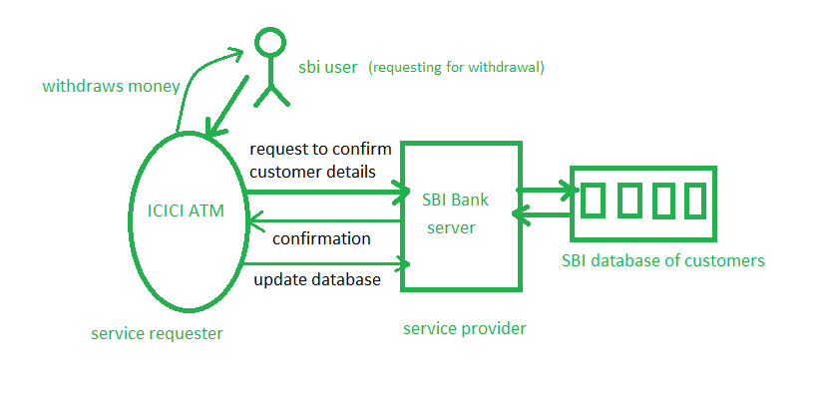

How do Web Services Work?
Web services use the request-response method to communicate among applications. For any communication, we need a medium and a common format that can be understood by everyone, in the case of web services medium is the internet and the common format is the XML (Extensible Markup Language) format as every programming language can understand the XML markup language.
A client is the one that requests some service from the server that is known as the service provider. The request is sent through a message which is in common XML format and in response to that request, the service provider will respond with a message in a common format (.i.e. XML).
Architecture of Web Service
Client Application
↓
HTTP Request
↓
Web Service Server
↓
Business Logic
↓
HTTP Response
↓
Client Application

Web Service Components
1. SOAP: As mentioned above SOAP stands for Simple Object Access Protocol. It is the protocol stating how the communication between the application is going to happen.
2. WSDL: It stands for Web Services Description Language which is the XML document containing the rules for communication among different software. It defines that:
- How that service can be accessed by the system requesting for it from other systems
- What is the name of the service
- What are the specific parameter needed for accessing that service, what would be the return type
- What are the error messages that would be displayed in case of any issue while accessing the data.
3. UDDI: Universal Description, Discovery, and Integration is the full form for the UDDI. It is a directory that provides us the detail that which software needs to be contacted for the particular type of data.

Types of Web Services
There are mainly two types of web services:
1. SOAP web services: SOAP stands for Simple Object Access Protocol. These protocols are based on XML which is a lightweight data exchange language. These protocols are independent of language and can be run on any platform.
SOAP supports both stateful and stateless operations. Stateful means that the server keeps track of the information received from the client on each request. While Stateless means that each request contains enough information about the state of the client and thus server does not need to bother about saving the state of the client thus increasing the speed of communication.
Many companies such as IBM, Microsoft are producing an implementation of SOAP into their systems.
2. RESTful web services: It stands for Representational State Transfer. They are also language and platform-independent and are faster in comparison to SOAP. Nowadays RESTful web services are more used than SOAP. They treat the data as resources. RESTful web services return data in JSON format or XML format. These web services create the object and send the state of the object in response to the client's requests, that's why known as Representational State Transfer.

